**Acknowledgement**

I am grateful to Professor Dr. Muhad. H. Miraz for his support and advice during my studies. For me, the teacher's great moral sentiments, deep knowledge, and broad vision have produced a positive academic impact to me. Being in the middle of it submerged me in a completely new way, causing me to not only embrace new ideas and set clear academic goals, but also to understand a lot of things.

In addition, I sincerely thank all the teachers in the Software Engineering Department of Xiamen University Malaysia for their selfless help. Their teachings have provided the theoretical basis for the discussion of this paper, and created many necessary conditions and learning opportunities. There are also classmates who get along day and night.

Finally, I would like to thank my parents and family. No one loves me more than you. Your love has made me deeply feel the beauty of life. Thank you for your understanding, encouragement and support. You are the ones that drive me for continuous progress.

Finally, I would like to express my sincere thanks to the experts and teachers who took time out of their busy schedules to review this paper. Due to my limited knowledge and writing level, it is inevitable that there will be some awkwardness in the writing of this article. I urge teachers and classmates to give advice.

**Abstract**

With the rapid development of society and the rapid increase of population, the shortage of land, energy and minerals will become increasingly serious. In order to ensure the normal operation of pillar industries such as industrial production, transportation, and energy collection, non-destructive testing technology plays an important role.

A kind of new detection methods based on artificial intelligence, as a new generation of non-destructive testing method, detects the early damage of ferromagnetic components and creates a detection concept that surpasses traditional non-destructive testing methods, which has attracted widespread attention from researchers around the world.

However, this technology is still in the early stage of development, its theoretical system is not perfect, the detection standards are relatively vague, and the goal of a quantitative and standardized mature detection technology has not yet been achieved.

In view of the above-mentioned characteristics of this technology, starting from basic research, based on the combination of conventional mechanical experiments and magnetic memory detection, this paper explores the characteristics of magnetic memory signals of various industrial steels under different mechanical states, and proposes a more practical image-based simulation method. It is a new type of mobile portable inspection detector which combining Internet of Things, computer vision technology and Steel Structure Damage. The image simulation method is used to process the experimental data, and then deal it with artificial intelligence.

This research is of great significance for detecting the damage degree of steel, which can help steel detection in modern society to be carried out quickly and maximize the utilization rate of steel. It can help them improve the economic efficiency of the enterprise.

**Keywords: Damage detection; Internet of Things; Raspberry Pi; Steel structure; Steel damage;**

**A Nondestructive Assessment Method for Damage Degree of Remanufactured Ferromagnetic Structures Based on YOLOv3 and the Internet of Things**

**Table of Contents**

1. Introduction - 4 -

1.1 Background - 5 -

1.2 Research Status - 6 -

1.3 Research Content - 8 -

2. Theoretical Basis - 8 -

2.1 Introduction to Internet of Things - 8 -

2.2 Introduction to Artificial Intelligence - 8 -

2.3 Introduction to YOLOv3 - 8 -

2.4 Introduction to Raspberry Pi - 11 -

2.5 Introduction to Fuzzy Set Theory - 12 -

3. Detection Principle - 12 -

3.1 Experimental Materials - 13 -

3.2 Experimental Method - 14 -

3.3 Processing Process - 16 -

4. Experimental Verification - 18 -

4.1 Introduction to Data Collections - 18 -

4.2 Experimental Content - 19 -

4.3 Experimental Results - 19 -

4.4 Results Evaluation - 20 -

5. Conclusion - 21 -

## Introduction

### Background

In the 21st century, protecting the global environment, building a circular economy and maintaining sustainable social development have become topics of common concern to all countries in the world. Remanufacturing engineering can enable mechanical and electrical products to continuously undergo technological transformation, so that the quality and performance of remanufactured products can reach or exceed the new products, while the cost is only 50% of the new products, energy saving 60%, material saving 70%, and can significantly reduce the adverse effects on the environment influence. It will promote the creation of an economical recycling, resource-saving and environment-friendly society.

Ferromagnetic materials have good strength, hardness, plasticity, toughness and other characteristics, and have been widely used in various fields of industry. Many key components in mechanical equipment are made of ferromagnetic materials, and many of these components are under the working conditions of repeated alternating loads, and fatigue failure is one of the main damage forms.

However, with the rapid development of modern industry, more and more equipment and workpieces have been used in high-temperature, high-speed, and high-load environments for a long time, so that equipment or workpieces are often in a "full load" or "overload" working state. As a result, the problem of fatigue failure has become increasingly prominent.

During the fatigue loading process, under the continuous action of alternating stress (or strain) below the static strength limit, various types of microscopic internal defects (such as dislocation, slip, stress-induced phase transformation, etc.) Evolves into macroscopic cracks, which then propagate and eventually lead to structural failure. According to statistics, in the modern industrial field, more than 80% of the structural damage is caused by fatigue failure.

Therefore, using advanced remanufacturing engineering technology to repair fatigued mechanical parts so that their quality and performance can meet or exceed new products is an effective way to upgrade waste equipment and meet the requirements of sustainable development strategies and economical society construction. If the parts after service are easily scrapped without life prediction, it will cause huge waste.

At the same time, the goal of the remanufacturing project is to make the used products meet or exceed the performance of the new products after remanufacturing. It will bring losses to the remanufacturing enterprises. Therefore, it is of great significance to predict the remaining life of ferromagnetic materials before remanufacturing.

### Research Status

#### *1.2.1 Traditional Method*

At present, ferromagnetic materials are widely used in the production of industrial equipment and workpieces, and accordingly, the non-destructive testing of equipment or workpieces made of such materials has also received great attention.

Using the principle that the defects of ferromagnetic components produce magnetic flux leakage under the action of an external strong magnetic field to detect the defects of components, it has been used as a conventional detection technology in the quality inspection of various ferromagnetic components. The mechanism is that the defects are under the action of strong magnetic fields. "Passively" produces "magnetic leakage", which facilitates the magneto-sensitive element to obtain the special magnetic signal at the defect and make judgments on the size and nature of the defect.

However, this method requires auxiliary and cumbersome magnetization equipment, and has the disadvantages of high energy consumption, demagnetization treatment after detection, and difficulty in implementing some in-service equipment, components or components with complex structures. In contrast, the ubiquitous "earth magnetic field" magnetizes various ferromagnetic components invisibly, making them all have weak "magnetism" that is difficult for people to detect.

In addition, studies have found that in the earth's magnetic field environment, under periodic or vibratory load conditions, the magnetization of ferromagnetic metals will increase significantly due to the effect of magneto-elasticity and magneto-mechanical effects. Under certain conditions, the use of sensitive weak magnetic detectors can perform work similar to traditional magnetic flux leakage detection.

Therefore, timely and accurate fatigue analysis to maximize the early detection of fatigue failure time has become the main direction of the current non-destructive testing technology development.

In the 1990s, at the 50th International Welding Academic Conference held in San Francisco, USA, Russian scholars represented by Professor Doubov put forward the relevant theory of metal stress concentration zone - metal microscopic change - metal magnetic memory effect, forming a set of A new metal diagnostic technology-metal magnetic memory detection technology.

With the help of the natural geomagnetic field, various microscopic defects inside the metal and the "active" response characteristics of local stress concentration to changes in the magnetic field, this technology claims to have the ability to diagnose the damage of ferromagnetic metal components at an early stage.

At present, most of the work done by scholars from various countries in the field of life prediction is for different materials, through various fatigue test forms (bending, rolling, torsion, vibration, tension and compression, etc.), and accumulating a large amount of fatigue performance test data. At the same time, according to the fatigue damage accumulation theory, the working conditions are simulated, and the life prediction model is established through mathematical and mechanical analysis, and then the component life is predicted. The whole process consumes huge financial, material and human resources, but the result is not satisfactory, which is often far from the actual situation (5~10 times).

### Research Content

## Theoretical Basis

### Introduction to Internet of Things

### Introduction to Artificial Intelligence

At present, artificial neural theory can be seen as a typical algorithm, and mathematical model support is very important and can play a major role. The basis is mainly the technical means of artificial neural network artificial intelligence, and the connection between them is very close, so at this stage through the effective application of artificial neural theory, it can be ensured that the information can be absorbed in a more timely manner.

The scientific and rational use of neural networks can also make this network popular in various fields. When carrying out fault detection work, artificial neural theory can be used to carry out the principle of interaction between multiple neurons and faults. application and analysis to find the exact location of the failure.

### Introduction to YOLOv3

#### *Traditional Detection Method*

Over the last decade, Convolutional Neural Networks have achieved ground-breaking breakthroughs in a variety of pattern recognition domains. CNN is a feedforward neural network, the artificial neural its response within a portion around the cell coverage area, for large image processing have outstanding performance.

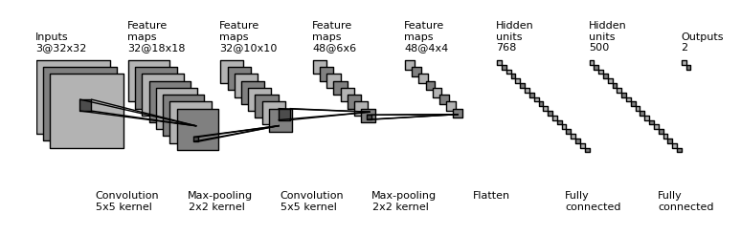

An input layer, hidden layers, and an output layer comprise a convolutional neural network. The convolution procedure creates a feature map as the convolution kernel slides along the input matrix for the layer, which then contributes to the input of the following layer.

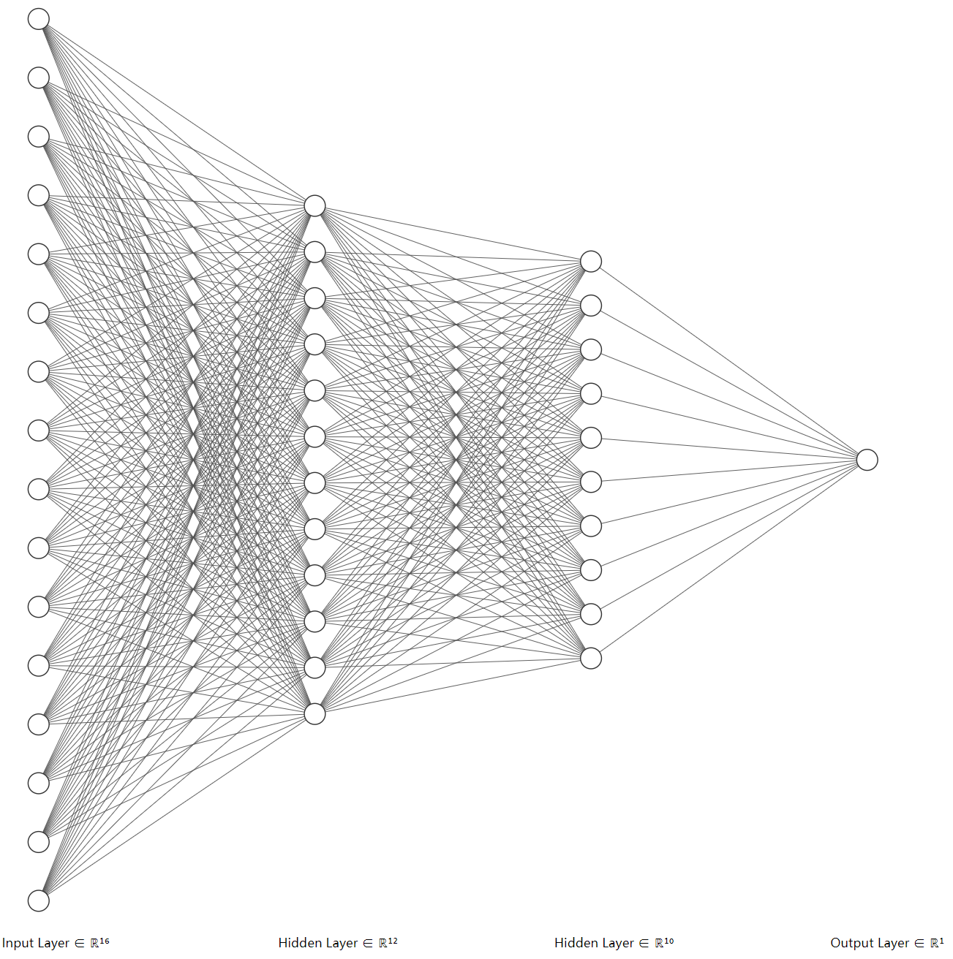

#### *YOLOv5 Detection Method*

Like YOLOv2, YOLOv3 still adopts multi-label classification. Multi-scale prediction uses the new network Darknet-53 to extract features.

Darknet-53 borrows the idea of resnet and adds a residual module to the network, which is conducive to solving the gradient problem of the deep network. Each residual module consists of two convolutional layers and a shortcut connection, 1, 2, 8 ,8,4 means that there are several repeated residual modules. In the entire v3 structure, there is no pooling layer and fully connected layer. The downsampling of the network is achieved by setting the stride of the convolution to 2. Whenever this volume is passed After layering, the size of the image will be reduced to half. The implementation of each convolutional layer includes convolution + BN + Leaky ReLu, and a zero padding is added after each residual module.

Overall, the input and output forms of Yolov3 are as follows: Input an image of 416*416*3, and obtain three different scales of prediction results through the darknet network. Each scale corresponds to N channels and contains the predicted information; The prediction results of anchors of each size of each grid. And in this project, we adopted YOLOv3

Therefore, here is the parameter of YOLOv3:

Scale: become **416x416x3**

Black box: output **13x13x2**

### Introduction to Raspberry Pi

Most of the things that a computer can do can be done on the Raspberry Pi, and the Raspberry Pi, with its low energy consumption, portability, GPIO and other characteristics, many things that are difficult to do on ordinary computers, but with the Raspberry Pi it is very suitable.

It is an ARM-based computer the size of a credit card, or more precisely, a single-board computer. Developed and maintained by the Raspberry Pi Foundation, a UK-registered charity, the Raspberry Pi was originally designed as a low-cost computer for teaching children about programming. And now it can be used to do a lot of interesting things.

The Raspberry Pi runs an operating system called Raspbian by default, which is an open-source operating system based on the Linux kernel and the Debian operating system. The operating system is loaded on a TF card, powered by USB. You only need to connect the mouse, keyboard and monitor or TV, and then you can design programs based on the Linux operating system.

### Introduction to Fuzzy Set Theory

The so-called fuzzy set theory is a common method and the most basic method in the current application of theoretical thinking. Relatively speaking, this method is relatively complicated, and it involves more subject knowledge content, but it is also relatively blurry.

There are two more important subjects, logic and fuzzy mathematics. In addition, there are some other disciplines, and the links between these disciplines are still very close, but they also have vague characteristics.

In this theory, different disciplines need to exist in a collective way for common application, so the combination of multiple disciplines is called fuzzy and the randomness of this theory is not very strong, mainly referring to the concept of the existence of things themselves, relatively fuzzy, the model can be distinguished, fuzzy data can be calculated, and relevant knowledge can be obtained. Using this method to detect faulty equipment can compare the detection results and the faults in time, and better solve the fault problem.

## Detection Principle

Traditional industrial manufacturing, due to the limitations of science and technology, still mainly uses manual detection methods to detect defects on the surface of products. Due to manual limitations and backward technology, this method is not only slow and inefficient to detect products, but also the process is prone to errors, resulting in inaccurate detection results.

In today's society, with the emergence and development of computer technology, artificial intelligence and other science and technology, and the in-depth research, surface defect detection technology based on machine vision technology has emerged. The emergence of this technology has greatly improved the efficiency of production operations, avoided the influence of operating conditions, subjective judgments, etc. on the accuracy of the detection results, and achieved better and more accurate surface defect detection and faster identification of product surface defects. .

Through artificial intelligence algorithms combined with machine vision technology, image data is used to detect defects such as spots, pits, scratches, chromatic aberration, and defects in products in real time, and supports industrial cameras, ultrasound, microwave, infrared and laser holography and X camera cameras and other different image sources to achieve accurate detection.

Product surface defect detection belongs to a kind of machine vision technology, which is to use computer vision to simulate the function of human vision, to collect, process, calculate, and finally carry out actual detection, control and application of images from specific objects. Product surface defect detection is an important part of machine vision inspection, and the accuracy of its detection directly affects the final quality of the product. Since the use of manual inspection methods has long been unable to meet the needs of production and modern process manufacturing, the use of machine vision inspection has overcome this problem, and the wide application of surface defect inspection systems has promoted high-quality production and manufacturing The development of intelligent automation.

### Experimental Materials

A total of two specimen materials were selected in this study: 18CrNi4A carburized steel and 45# steel.

18CrNi4A carburized steel has high tensile strength and good comprehensive mechanical properties after quenching and low temperature tempering. It is suitable for the manufacture of key heavy-duty gears and shaft parts. It can also be used as carburized bearing steel. has been widely used. 45# steel is a commonly used medium carbon steel, which is widely used in various industrial fields such as automobiles and ships.

The following figure shows the microstructure photos of 18CrNi4A and 45# steel. The first picture shows the microstructure photos of 18CrNi4A carburized steel after quenching and low temperature tempering, and its microstructure is needle-like back. Fire martensite structure.

Another picture shows the microstructure photo of 45# steel, whose microstructure consists of pearlite, ferrite and a small amount of tertiary cementite.

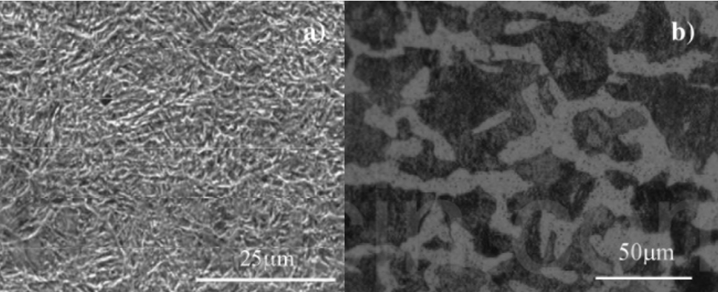

The chemical composition and mechanical properties of the test materials are shown in the following table.

1. Chemical Constitution of the Speciments

|  |  |  |  |  |  |  |  |
| --- | --- | --- | --- | --- | --- | --- | --- |
|  | **C** | **Mn** | **Si** | **S** | **P** | **Cr** | **Ni** |
| **18CrNi4A** | 0.15~0.20 | 0.30~0.60 | ≤0.35 | ≤0.010 | ≤0.015 | 0.80~1.10 | 3.75~4.25 |
| **45#** | 0.40~0.50 | 0.50~0.80 | 0.17~0.37 | ≤0.040 | ≤0.040 | 0.15 | ≤0.25 |

### Experimental Method

#### *Data Pre-Processing*

#### *Damage Detection*

#### *data compression*

Run-length encoding, in order to reduce the size of the submitted file, our indicator object value adopts the method of run-length encoding.

Run-length coding is an important coding method for raster data compression. Its basic idea is: for a raster image, there are often several adjacent points in the row (or column) direction that have the same attribute code, so a certain number of points can be used. A way to compress those duplicate records. The coding scheme is that only when the code of each row (or column) of data changes, the code and the number of repetitions of the same code are sequentially recorded, thereby realizing data compression.

#### *Overall structure*

In our design concept, we build an integrated Internet of Things through Raspberry Pi with electronic cameras, and this Internet of Things is only used as an integrated entry system.

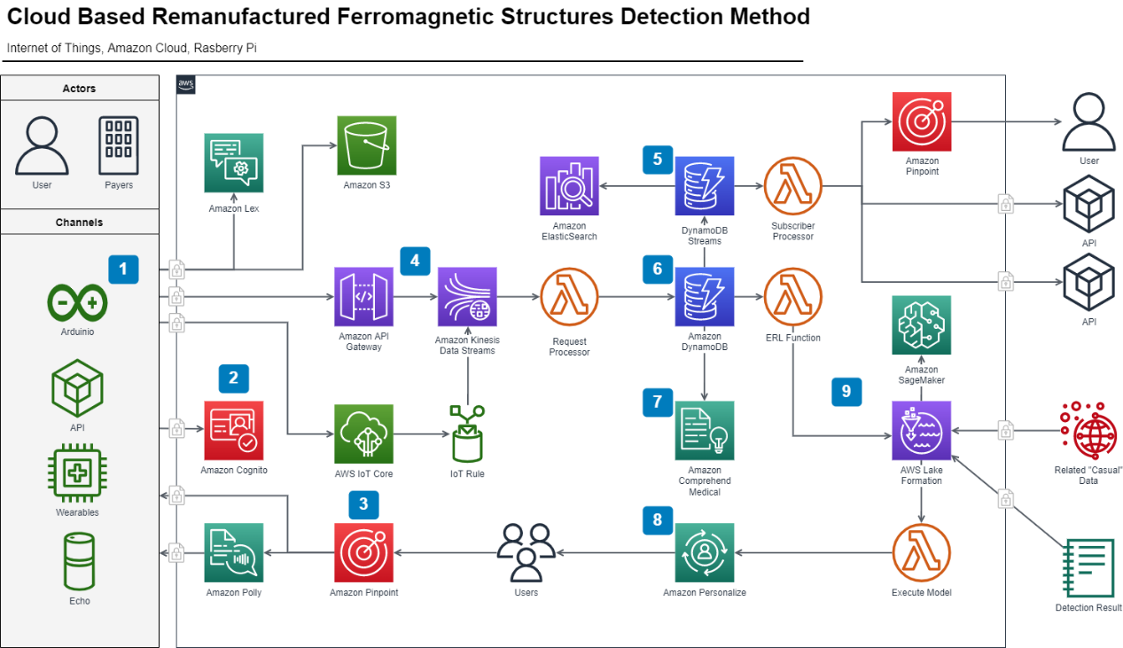

We combine the system with Amazon Cloud, and the final processing terminal falls on Amazon Cloud, steel detection processing is performed by the cloud, and the processing result is returned at last.

### Processing Process

Step 1: Obtain prediction results from features

1. YOLOv3 extracts multiple feature layers for target detection. A total of three feature layers are extracted. The three feature layers are located in different positions of the backbone feature extraction network darknet53. They are located in the middle layer, middle and lower layer, and bottom layer. The shapes of the three feature layers are respectively (52,52,256), (26,26,512), (13,13,1024), these three feature layers are used to stack and splice with other feature layers after upsampling
2. The third feature layer (13,13,1024) performs 5 convolution processing. After processing, one part is used for convolution + upsampling, and the other part is used to output the corresponding prediction results (13,13,75), Conv2D 3×3 and Conv2D1×1 two convolutions play the role of channel adjustment, adjusted to the size required by the output.
3. After convolution + upsampling, the feature layer of (26, 26, 256) is obtained, and then it is spliced ​​with the feature layer (26, 26, 512) in the Darknet53 network, and the obtained shape is (26, 26, 768), and then convolution is performed 5 times After processing, one part is used for convolution up-sampling, and the other part is used to output the corresponding prediction results (26, 26, 75). Conv2D 3×3 and Conv2D1×1 are the same as above for channel adjustment
4. After that, splice the feature layer of convolution + upsampling in 3 with the feature layer of shape (52,52,256), and then convolve to obtain the feature layer of shape (52,52,128), and finally Conv2D 3×3 And Conv2D1×1 two convolutions to get (52,52,75) feature layer. There are three red boxes in the last picture. The reason is that some objects are relatively large in the picture, so they are detected by 13×13. If the objects are relatively small in the picture, they will be classified as 52×52 for detection.

Step 2: Decoding the prediction result

Reason for decoding the prediction result: The prediction result (red box) does not correspond to the position of the final prediction box on the picture, and it needs to be decoded)

The prediction principle of yolov3 is to divide the entire image into 13x13, 26x26, 52x52 grids, and each network point is responsible for the detection of an area. The decoding process is to calculate the coordinates bx, by, width and height bw, bh of the last displayed bounding box, so that the position of the bounding box is obtained. The calculation process is shown in the figure (b-the abbreviation of bounding box)

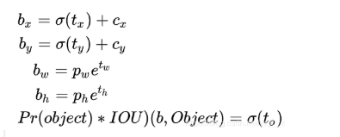

(cx,cy): The number of grids that differ from the upper left corner of the grid where the point is to the upper left corner.

(pw,ph): the side length of the a priori box

(tx,ty): the offset of the target center point relative to the upper left corner of the grid where the point is

(tw,th): predict the width and height of the border

σ: activation function, we used LeakyRuLU

Step 3: Sort the predicted bounding box scores

This step is to filter out the boxes with the highest probability. Take out each type of box with a score greater than a certain threshold and sort the scores. Then use frame position and score for non-maximum suppression. Finally, the bounding box with the highest probability can be obtained, which is the last displayed box.

Follow we will use the rainbow six gaming screenshot to display the selection process. First, we can see there are three border and the score is 0.67, 0.77, 0.92 in incremental order.

## Experimental Verification

### Introduction to Data Collections

Because in the steel inspection in the actual production environment, we may obtain a variety of steel defects in the sample data, so our sample data contains a variety of types.

It can be clearly seen from the figure that there are differences between different types of defects, such as plaque, cracking, pitting, etc.; there are also differences within the same type of defects, such as scratch defects, which can be horizontal scratches, vertical scratches, etc. scratches, slanted scratches, etc. In addition, images of the same defect class may also have different grayscales due to changes in lighting and materials.

The images below are examples of six typical surface defects, each with a resolution of 200*200 pixels.

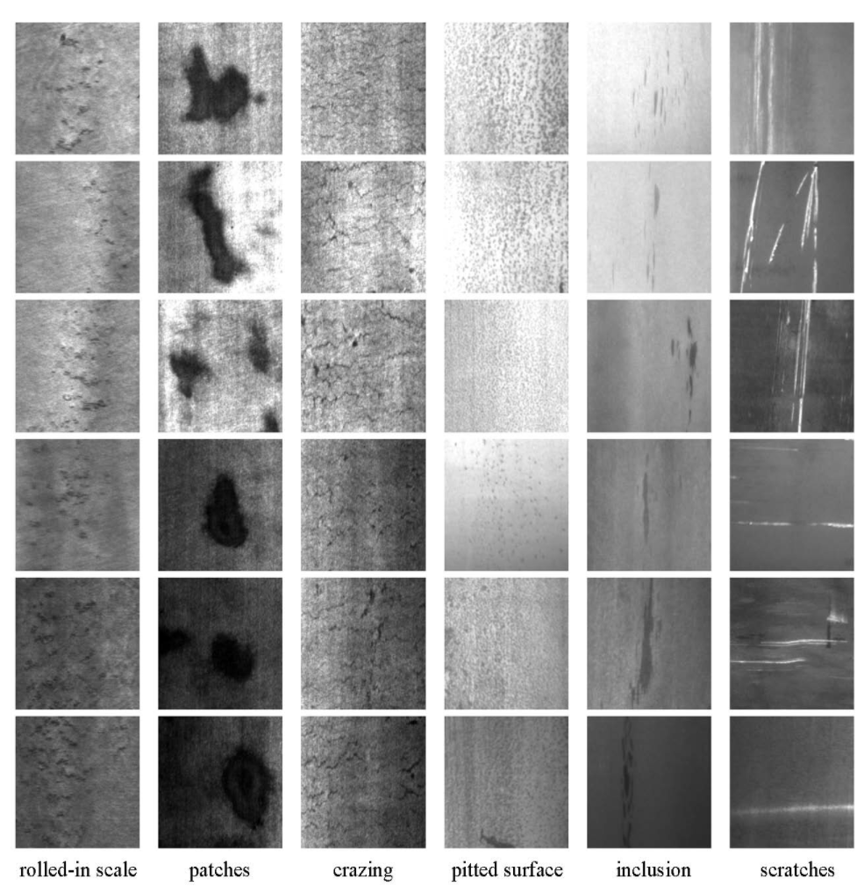

### Experimental Content

### Experimental Results

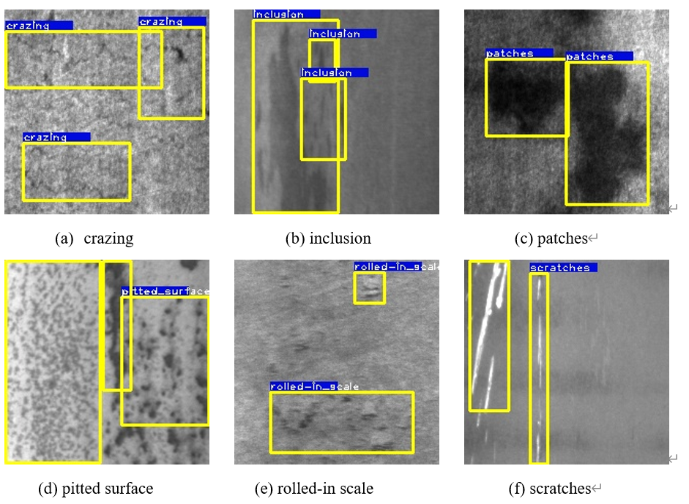

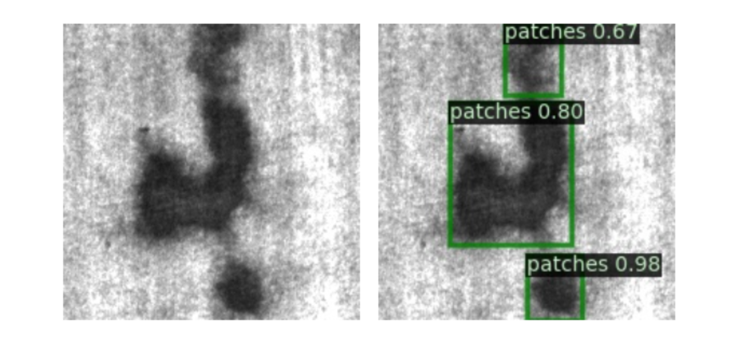

### Results Evaluation

We evaluate mainly in terms of the average dice coefficient, the Dice system, which can be used to compare the pixel consistency between predicted separations and their corresponding ground truths, which can be given by the following formula.

In addition, other evaluation indicators will also be introduced, including Accuray, Precision, Recall.

## Conclusion

Steel is one of the most important building materials of modern times. Steel buildings are resistant to natural and man-made wear which has made the material ubiquitous around the world. To help make production of steel more efficient, this competition will help identify defects.

Severstal is leading the charge in efficient steel mining and production. They believe the future of metallurgy requires development across the economic, ecological, and social aspects of the industry—and they take corporate responsibility seriously. The company recently created the country’s largest industrial data lake, with petabytes of data that were previously discarded. Severstal is now looking to machine learning to improve automation, increase efficiency, and maintain high quality in their production.

The production process of flat sheet steel is especially delicate. From heating and rolling, to drying and cutting, several machines touch flat steel by the time it’s ready to ship. Today, Severstal uses images from high frequency cameras to power a defect detection algorithm.

In this competition, we are helping engineers to improve the algorithm by localizing and classifying surface defects on a steel sheet.

In addition, we can also keep manufacturing standards for steel high and enable Severstal to continue their innovation, leading to a stronger, more efficient world all around us.